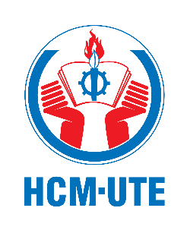 | HCMC UNIVERSITY OF TECHNOLOGY AND ENGINEERING  Add: No 1 Vo Van Ngan Street, Thu Duc Ward, Ho Chi Minh City  Tel: (+84 - 028) 38968641 - (+84 -028) 38961333 - (+84 -028) 37221223  Fax: (+84 - 028) 38964922  E-mail: oia@hcmute.edu.vn

LETTER OF MEDIUM OF INSTRUCTION
To Whom It May Concern
This is to certify that Mr. Nguyen Văn A has successfully fulfilled the academic requirements for the Bachelor of Engineering in Mechatronics Engineering Technology at Ho Chi Minh City University of Technology and Engineering (HCMUTE), Vietnam. His studies were conducted from September 2017 to November 2023, and he was formally conferred with the degree on November 8, 2023.
It is important to note that the medium of instruction for the entirety of this rigorous four-year program was exclusively in English. This included all lectures, assignments, examinations, and project work, ensuring that Mr. A has been extensively trained in technical communication in English, both written and spoken.
Mr. Tan’s academic record is registered under the University ID number 17146064.
I hereby affirm that the above-mentioned details are accurate and true to the best of my knowledge. This certification is issued at the request of Mr. Tan for the purpose of application to graduate programs and other academic pursuits abroad.

Signed by Faculty of Advanced Education
Address: 01 Vo Van Ngan Street, Thu Duc Ward, Ho Chi Minh City, Vietnam
Tel: (+84 - 028) 37222763
Email: fae@hcmute.edu.vn

